Project Title: Inventory Management System for Retailers Project Design Phase-I - Solution Fit Template

Team ID: PNT2022TMID07849

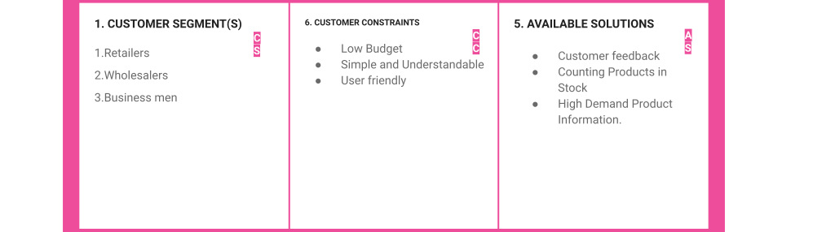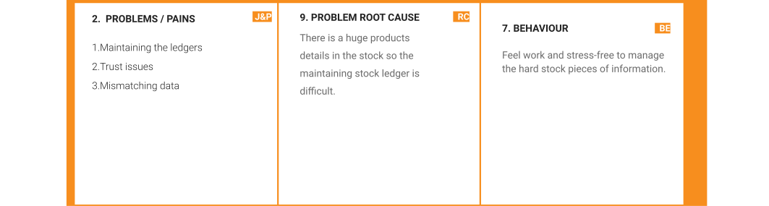

|  |  |  |  |  |  |
| --- | --- | --- | --- | --- | --- |
|  | 3. TRIGGERS  Hearing about the web application through social media, neighborhood retailers, and friends. | TR | 10. YOUR SOLUTION  SL   * Benefiting the retailers by scanning the product barcode and generating the invoice. * By Collecting regular Orders and customer details the high-demand products will be identified. | 1. CHANNELS of BEHAVIOR CH 8.1 ONLINE   Check the Stock information whenever needed.  8.2 OFFLINE  Add a new variety of product details to the stock. |  |
| 4. EMOTIONS: BEFORE / AFTER  BEFORE: Difficult to maintain, Trust issues  AFTER: More Profit, Best Analysis |  |